Zachor – To Remember. The Story of Menachem and Fred

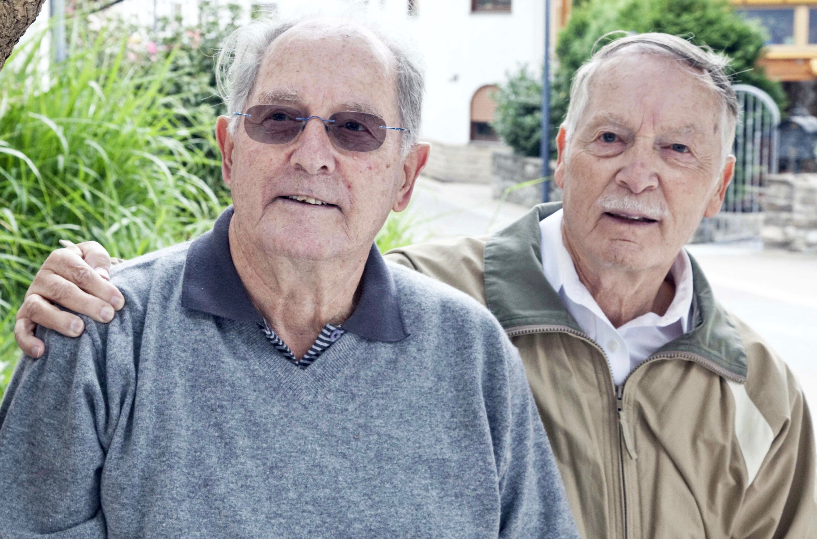 | Ilay Elmkies, a soccer player on the Israeli national youth team, guides us through the life story of Fred (born 1929) and Menachem (born 1932). They spent part of their childhood years in the village of Hoffenheim in southwest Germany. In October 1940, their parents and they were deported to Gurs Internment Camp in the south of France. They only survived the Shoah because their parents were prepared to make the difficult decision to separate from them and place them in an orphanage. After the war, the boys went their separate ways. Fred immigrated to the US, where he became a respected aerospace engineer. He died in 2013. Menachem immigrated to Israel in 1948, where he worked in the field of education. He is currently living in Jerusalem.
Annotations:
Night of Broken Glass: On November 9-10, 1938, Jewish synagogues throughout Germany were torched. Members of the SA (the Nazi Stormtroopers) and the SS smashed the storefront windows of Jewish-owned businesses, vandalized the homes of Jewish citizens and assaulted their occupants. According to ‘official’ estimates, this state-organized pogrom resulted in 91 fatalities and the destruction of 267 places of worship and community centers as well as 7,500 businesses. In fact, more than 1.300 people died as a direct or indirect result of that night’s violence. More than half of the synagogues and minor places of worship in Germany and Austria were severely damaged or completely destroyed – at least 1,400 in total.
http://www.dhm.de/lemo/kapitel/ns-regime/ausgrenzung-und-verfolgung/novemberpogrom-1938.html

Deportation of 1940 (Wagner-Bürckel Action): On October 22, 1940, the entire Jewish population of the southwestern German regions of Baden, the Palatinate and the Saarland was deported to Gurs Internment Camp in the south of France. Acting on their own initiative, the Gauleiters (regional Nazi party leaders) of Baden, Robert Wagner, and of the Saar-Palatinate, Josef Bürckel, had more than 6,500 Jews from 137 municipalities in southwestern Germany deported. The following day the area was declared judenfrei (Jew-free).

Gurs Internment Camp: In 1939, the French government set up an improvised internment camp in Gurs in southwestern France to control refuges belonging to the Republican side of the Spanish Civil War. Following the armistice between Vichy France and Nazi Germany in World War II, the camp was used as an internment camp for Jews from the French regions of Alsace and Lorraine and the Jews from southwestern Germany deported as part of the Wagner-Bürckel Action. Due to the appalling conditions at the camp a large number of inmates soon died from illnesses and starvation. From 1942 on, the camp’s inhabitants were sent to extermination camps in eastern central Europe.

Orthodox (religious): Orthodox Judaism is one of the main currents of modern Judaism. Orthodox Jews view the Torah, both written and oral, as literally revealed by God and place great importance on observing religious laws.

Kibbutz: Kibbutz is the Hebrew expression denoting a collective community in Israel. The kibbutz is a unique rural community – a system based on the principles of mutual help and social equality, a socio-economic system where people share both labor and possessions.
http://www.hagalil.com/israel/kibbutz/kibbutz.htm

Tasks

Pre-viewing: Write down (in one or two sentences) the meaning of the word home for you: ________________________________________________________________________
________________________________________________________________________
________________________________________________________________________
________________________________________________________________________

While-viewing: Mark the correct answer.

1.) How many Jews used to live in Germany in 1933? How many of these were living within the modern-day state of Baden-Württemberg and how many in Hoffenheim?
a.) 2 millions 23,400 26
b.) 499,682 30,640 18
c.) 110,000 10,580 56

2.) In rural Germany many Jews used to work as
a.) butchers
b.) cattle traders
c.) bankers

3.) From 1937 on, Manfred (Fred) attended the Jewish school in
a.) Heidelberg
b.) Mannheim
c.) Frankfurt

4.) During the Night of Broken Glass, the synagogue in Hoffenheim was
a.) spared
b.) set alight
c.) destroyed

5.) What did Karl Mayer do with his World War I decorations?
a.) He kept them.
b.) He threw them to the ground.
c.) He had to hand them in.

6.) How much time did Manfred and Heinz spend at Gurs?
a.) 3 months
b.) 4 months
c.) 6 months

7.) When was Auschwitz concentration camp liberated by the Soviet army?
a.) 27 January 1945
b.) 16 April 1945
c.) 8 May 1945

8.) Which state was founded in 1948?
a.) Switzerland
b.) Jordan
c.) Israel

9.) At which university did Menachem devote himself to the study of natural sciences?
a.) Jerusalem
b.) Haifa
c.) Tel Aviv

10.) Fred worked in
a.) the automobile industry
b.) the food industry
c.) aeronautics

11.) When was the first time that Menachem returned to Hoffenheim?
a.) 1954
b.) 1974
c.) 1964

12.) Players from TSG 1899 Hoffenheim’s youth team participated in the creation of
a.) A book
b.) A memorial stone
c.) A hiking trail

Post-viewing:
At the end of the film, Ilay talks about the meaning of zachor – remembering. Discuss whether it is important to engage with the history of one’s family, one’s region and one’s country, and to pass on that memory. Write about 2-3 sentences on the subject.
____________________________________________________________________________________________________________________________
____________________________________________________________________________________________________________________________
____________________________________________________________________________________________________________________________

Teachers‘ notes:

This lesson plan is aimed at 45 minutes but it can also be expanded. It is recommended for students from the ninth form or older. It is especially recommended for use during replacement lessons in language & literature, ethics, religious education, and history classes.
We suggest the following approach:

Time | Stundent/Teacher Activity | Dynamic | Media
3 min | Approaching topic of lesson | frontal
5 min | Teachers hands out worksheet  Students read tasks  Introduction  Explaining key terms | Private reading | Worksheet
25 min | Students deal with pre-viewing task (2min)  Students watch film, marking correct answers (18min)  Students deal with post-viewing tasks (5min) | watching,  reflecting | Film Zachor  Worksheet
12 min | Teacher checks students’ answers  Teacher discusses students’ response to film and concludes lesson | Class discussion | Overhead transparency  (with solutions)

Solutions:

1.) b
2.) b
3.) a
4.) c
5.) b
6.) b
7.) a
8.) c
9.) a
10.) c
11.) b
12.) c
________________________________________________________________________
Devised by: Jutta Stier, Wilhelmi-Gymnasium Sinsheim, Alan Götz, Hartmanni-Gymnasium Eppingen, and Michael Heitz, Albert-Schweitzer-Schule Sinsheim, June 2018.

